Digital triage: the operating model, not the widget
Sussex PCPC Digital Innovation Community of Practice, general practice webinar series, 7 July 2026
Our second Community of Practice session brought together general practice, PCN, LMC, NHS England and transformation colleagues from across Sussex to look at digital triage — a topic where, as with Ambient Voice Technology in May, the technology has raced ahead of shared understanding of how to implement it well. The pertinent question is no longer what product to use but what operating model makes triage safe, workable and inclusive. The headline, from every presenter and every angle: treat digital triage as a whole-practice access model, not a front-door widget. Demand data, staffing, triage skill, appointment rules, patient communication and feedback loops all move together. The product is the easy part.
The contractual frame
Dr Chrissie Clayton (Surrey & Sussex LMCs) opened with the essentials. Triage is not the consultation: it establishes what support a patient needs, how quickly, and who is best placed to provide it. Contractually: equity of access across phone, online and walk-in, with online forms kept on for non-urgent access throughout core hours (08:00–18:30); proxy completion by carers or staff is part of the contract, not a workaround; and under 2026/27, any request the practice determines to be clinically urgent must be dealt with the same day. The key word is determines — the practice’s clinical judgement counts, not the patient’s perception, and urgent needs can still be signposted same-day (Pharmacy First being the obvious example). Broken into its real layers — urgency, clinical versus administrative, modality, who decides and acts, language and access needs — triage is genuinely complicated, which is precisely why it deserves deliberate design.
The national picture: Intelligent Navigation
Lucy Marsden (NHS England) set out the direction: Intelligent Navigation accelerated towards a unified access point in every citizen’s hands by 2030 — accurate triage inside NHS App navigation, diverting demand to lower-acuity care. The economics are stark: which front door a patient uses largely drives cost per contact (Pharmacy First ~£17, GP face-to-face ~£37, urgent care centre ~£114, major A&E ~£368; a non-elective bed ~£901/day). With one in seven people already using generative AI to self-diagnose, the design answer is a neutral coordinator — a plug-and-play orchestration layer any standards-compliant tool can connect to, with no supplier lock-in, the patient staying on NHS architecture at every point, and iterative go-lives (pilots live at Wealden Ridge and in London).
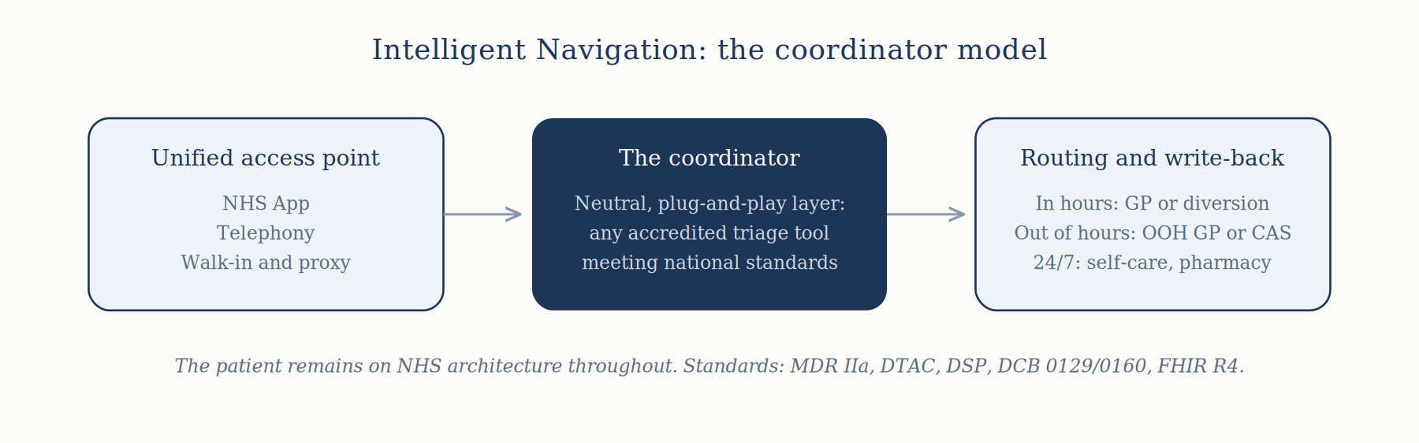
A note on AI type: most certified triage tools are narrow AI — probabilistic or rules-based engines whose logic is inspectable and reproducible, which is what makes them certifiable as Class IIa medical devices. Generative LLMs are black boxes whose assurance question changes from “does the logic match the clinical model?” to “how do we bound and evidence behaviour we cannot fully explain?”. When evaluating any product, ask which kind of AI you are buying and what the certification covers.
Wealden Ridge Medical Partnership: Visiba AI triage in the NHS App
I presented Wealden Ridge’s journey from a phone-led 8am rush to AI-assisted triage embedded in the NHS App — the first integration of its kind, live since December 2025 across 23,000 patients. Visiba is a Class IIa certified device: it prioritises, it does not diagnose; the duty doctor decides. This is deliberately not total triage: urgent access is triaged, routine appointments book directly.
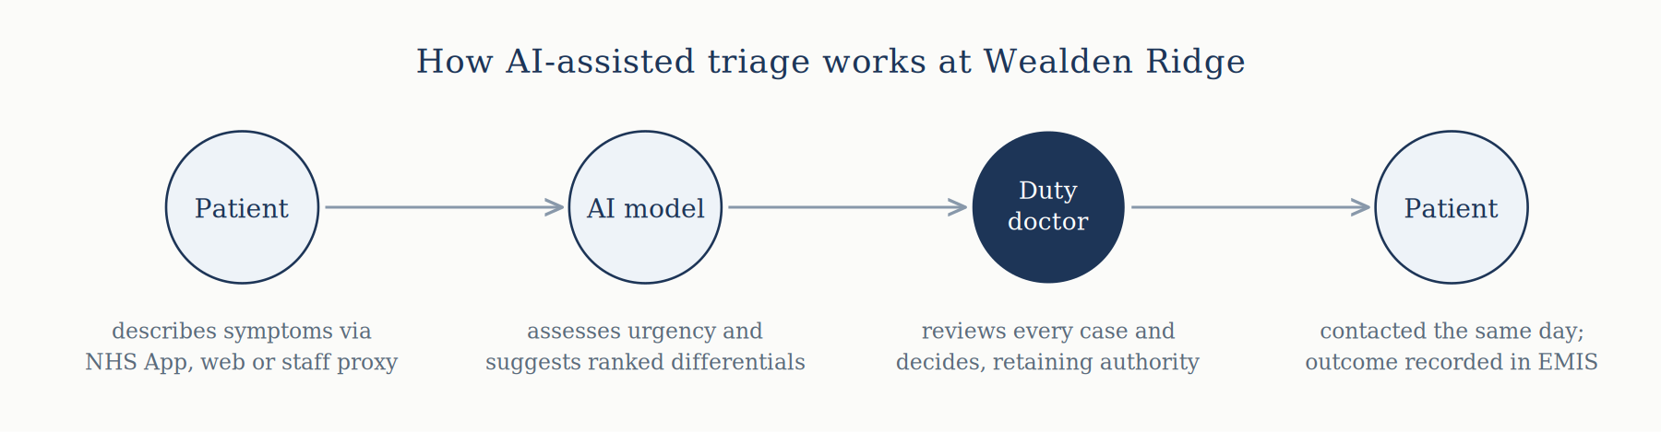
The data (matched periods, Dec–Mar): inbound calls down 23%, queue volumes down 29%, 55% of cases arriving via the App within two months; same-day work down 39% and week-ahead up 30% — once requests are properly triaged, most turn out not to need same-day care, and are routed back to the clinician who knows the patient. We are using triage to prioritise continuity. The honest bit: average call time is up ~25% and queue waits ~40% (proxy completion takes longer than booking used to), and some patients dislike being asked why they want an appointment — true of all triage, not just the digital kind.
Safety: we chose Class IIa (independently verified) over self-certified Class I, alongside our own DCB 0160 safety case, hazard log and DPIA; safety-critical presentations (pregnancy, under-1s, mental health crisis) bypass AI questioning entirely. Independent validation with Imperial College found 83.7% agreement, no significant undertriage and low automation bias; divergence sat at the upper end of urgency, where a GP with the notes can safely downgrade — context is general practice’s advantage. The AI also produced more conformity across clinicians, acting as a quiet safety net for junior colleagues. On Yellow Card reporting: the manufacturer carries the legal duty, but the MHRA strongly encourages practices to report all suspected AI inaccuracies — a clinician downgrading on knowledge of the patient is judgement; the tool getting it wrong on the information given is a suspected device error, and gets reported.
Alliance for Better Care: SystemConnect and the proven model
Chloe Burchell (ABC) drew on supporting ~20 practices, opening with a cautionary tale: bolting eConsult onto an unchanged model — a few reserved slots, requests everywhere, first come first served — was “completely the wrong way to look at it”. The gains come when the whole operating model is redesigned: done properly, with real demand data, ABC support practices to run an uncapped access model sustainably. Her success factors: know baseline capacity before launch; close quick wins on the day; take patient-initiated follow-up seriously; strip forms back to what your population will use; co-locate the duty team on one list; engage patients and staff early; retain non-digital routes. Crucially, inclusion does not have to suffer — reception have more time to help non-digital patients precisely because most demand arrives online, and every request is prioritised on clinical need, not contact route.
To “that won’t work for us”, Orchard Surgery is the answer: a markedly elderly population, low prior eConsult uptake — yet digital access hit ~64% in week one and sits at ~70%, with overall demand unchanged. A year on: the 600-plus waiting list gone, routine waits down over four weeks, 8–9am calls down 30–40%, better duty doctor days, no new staff.
Vita Healthcare: AccuRx Total Triage across five sites
A worked example from the session materials: total triage across five sites and ~40,000 patients, triaged by experienced paramedic practitioners. Their lessons: audit demand across all streams before go-live; put every request through one funnel (side-door email routes create missed work and incomplete data); make inclusion operational — proxy completion, care-home forms, red-flag checks; review one to two months after launch; and be honest that open access exposes finite capacity, so expectations must be actively managed. Kirstie Ingram (South Downs Health and Care) closed with “don’t reinvent the wheel”: the ICB’s Online Consultation Spotlight blueprints and webinars cover the main products across Sussex, and the Provider Collaborative is mapping who is doing what to link practices up.
Doing it well: a combined checklist
- Map a typical day’s demand against capacity before changing the front door.
- Choose your triage scope deliberately — total triage or urgent access only — then redesign the appointment book before switch-on (RAG-rated slots, a dynamic cap linked to real capacity).
- Check the contractual position: equity across routes, forms on in core hours, same-day response for clinically urgent requests.
- Decide who triages and confirm their skill and scope; keep the clinician in charge — AI prioritises, the duty doctor decides.
- Route everything through one funnel and close the side doors.
- Build proxy completion and non-digital routes into the standard workflow, not as exceptions.
- Confirm clinical safety arrangements (DCB 0160, hazard log, safety case) and know what kind of AI the product contains.
- Plan for predictable pressure (Mondays, bank holidays) and template patient communications before go-live.
- Review at one to two months, keep a learning log, and define success measures up front: call volumes, queue waits, route mix, care-type shift, waits and feedback.
Next up
We planned half an hour, extended to an hour, and still ran over — so a follow-up is planned for September, possibly on the ethics and governance of AI, and we are exploring how dedicated clinical safety officer capacity might be structured across Sussex. Meanwhile, don’t miss the cybersecurity webinar on 17 July, 1–2pm, hosted by South Downs Health and Care. The recording and resources from this session will be published on the Sussex PCPC Digital Innovation webpage and shared via the primary care bulletin. Three very different products produced strikingly consistent learning: digital tools in general practice succeed or fail on implementation, not features.
With thanks to Dr Chrissie Clayton (Surrey & Sussex LMCs), Lucy Marsden (NHS England), Chloe Burchell (Alliance for Better Care), Kirstie Ingram (South Downs Health and Care), Dr James Simpkin for hosting, and everyone who attended. Got a triage SOP, appointment-book design, RAG definitions, comms templates or a case study to share? Contact Kirstie or the CoP organisers.
Dr Ragu Rajan, Digital Lead, Sussex PCPC

